trip1.html
<!DOCTYPE html>
<html lang="en">
<head>
<meta charset="UTF-8">
<meta name="viewport" content="width=device-width, initial-scale=1.0">
<title>Document</title>
<style>
body{
background-color: #BBD6FD;
}
</style>
</head>
<body>
<center><h1>trip images first page</h1></center>
<p>Lorem ipsum dolor, sit amet consectetur adipisicing elit. Fugiat unde quod odio ut quis iusto harum facere soluta? Aperiam cum placeat quos harum odio magni, facilis unde asperiores illum dicta.</p>
<img src="images/img1.avif" alt="">
<img src="images/img2.avif" alt="">
<img src="images/img3.avif" alt="">
<img src="images/img4.avif" alt="">
<img src="images/img5.avif" alt="">
<img src="images/img6.avif" alt="">
<img src="images/img7.avif" alt="">
<img src="images/img8.avif" alt="">
<img src="images/img9.jpg" alt="">
<img src="images/img10.avif" alt="">
<hr>
<hr>
<center><a href="trip5.html">back</a> <a href="trip2.html">next</a></center>

</body>
</html>

Trip2.html
<!DOCTYPE html>
<html lang="en">
<head>
<meta charset="UTF-8">
<meta name="viewport" content="width=device-width, initial-scale=1.0">
<title>Document</title>
<style>
body{
background-color: #BBD6FD;
}
</style>
</head>
<body>
<center> <h1>trip images second page</h1></center>
<p>Lorem ipsum dolor, sit amet consectetur adipisicing elit. Fugiat unde quod odio ut quis iusto harum facere soluta? Aperiam cum placeat quos harum odio magni, facilis unde asperiores illum dicta.</p>
<img src="images/img1.avif" alt="">
<img src="images/img2.avif" alt="">
<img src="images/img3.avif" alt="">
<img src="images/img4.avif" alt="">
<img src="images/img5.avif" alt="">
<img src="images/img6.avif" alt="">
<img src="images/img7.avif" alt="">
<img src="images/img8.avif" alt="">
<img src="images/img9.jpg" alt="">
<img src="images/img10.avif" alt="">
<hr>
<hr>
<center><a href="trip1.html">back</a> <a href="trip3.html">next</a></center>

</body>
</html>

Trip3.html
<!DOCTYPE html>
<html lang="en">
<head>
<meta charset="UTF-8">
<meta name="viewport" content="width=device-width, initial-scale=1.0">
<title>Document</title>
<style>
body{
background-color: #BBD6FD;
}
</style>
</head>
<body>
<center> <h1>trip images third page</h1></center>
<p>Lorem ipsum dolor, sit amet consectetur adipisicing elit. Fugiat unde quod odio ut quis iusto harum facere soluta? Aperiam cum placeat quos harum odio magni, facilis unde asperiores illum dicta.</p>
<img src="images/img1.avif" alt="">
<img src="images/img2.avif" alt="">
<img src="images/img3.avif" alt="">
<img src="images/img4.avif" alt="">
<img src="images/img5.avif" alt="">
<img src="images/img6.avif" alt="">
<img src="images/img7.avif" alt="">
<img src="images/img8.avif" alt="">
<img src="images/img9.jpg" alt="">
<img src="images/img10.avif" alt="">
<hr>
<hr>
<center><a href="trip2.html">back</a> <a href="trip4.html">next</a></center>

</body>
</html>

trip4.html
<!DOCTYPE html>
<html lang="en">
<head>
<meta charset="UTF-8">
<meta name="viewport" content="width=device-width, initial-scale=1.0">
<title>Document</title>
<style>
body{
background-color: #BBD6FD;
}
</style>
</head>
<body>
<center> <h1>trip images fourth page</h1></center>
<p>Lorem ipsum dolor, sit amet consectetur adipisicing elit. Fugiat unde quod odio ut quis iusto harum facere soluta? Aperiam cum placeat quos harum odio magni, facilis unde asperiores illum dicta.</p>
<img src="images/img1.avif" alt="">
<img src="images/img2.avif" alt="">
<img src="images/img3.avif" alt="">
<img src="images/img4.avif" alt="">
<img src="images/img5.avif" alt="">
<img src="images/img6.avif" alt="">
<img src="images/img7.avif" alt="">
<img src="images/img8.avif" alt="">
<img src="images/img9.jpg" alt="">
<img src="images/img10.avif" alt="">
<hr>
<hr>
<center><a href="trip3.html">back</a> <a href="trip5.html">next</a></center>

</body>
</html>

Trip5.html
<!DOCTYPE html>
<html lang="en">
<head>
<meta charset="UTF-8">
<meta name="viewport" content="width=device-width, initial-scale=1.0">
<title>Document</title>
<style>
body{
background-color: #BBD6FD;
}
</style>
</head>
<body>
<center><h1>trip images second page</h1></center>
<p>Lorem ipsum dolor, sit amet consectetur adipisicing elit. Fugiat unde quod odio ut quis iusto harum facere soluta? Aperiam cum placeat quos harum odio magni, facilis unde asperiores illum dicta.</p>
<img src="images/img1.avif" alt="">
<img src="images/img2.avif" alt="">
<img src="images/img3.avif" alt="">
<img src="images/img4.avif" alt="">
<img src="images/img5.avif" alt="">
<img src="images/img6.avif" alt="">
<img src="images/img7.avif" alt="">
<img src="images/img8.avif" alt="">
<img src="images/img9.jpg" alt="">
<img src="images/img10.avif" alt="">
<hr>
<hr>
<center><a href="trip4.html">back</a> <a href="trip1.html">next</a></center>

</body>
</html>

Output screens:
Screen1 :
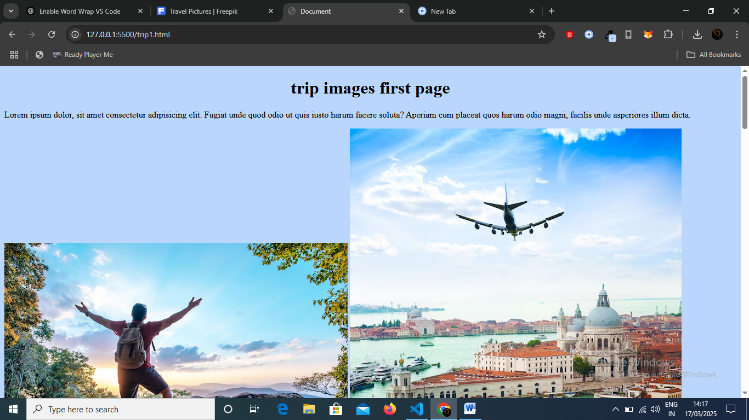
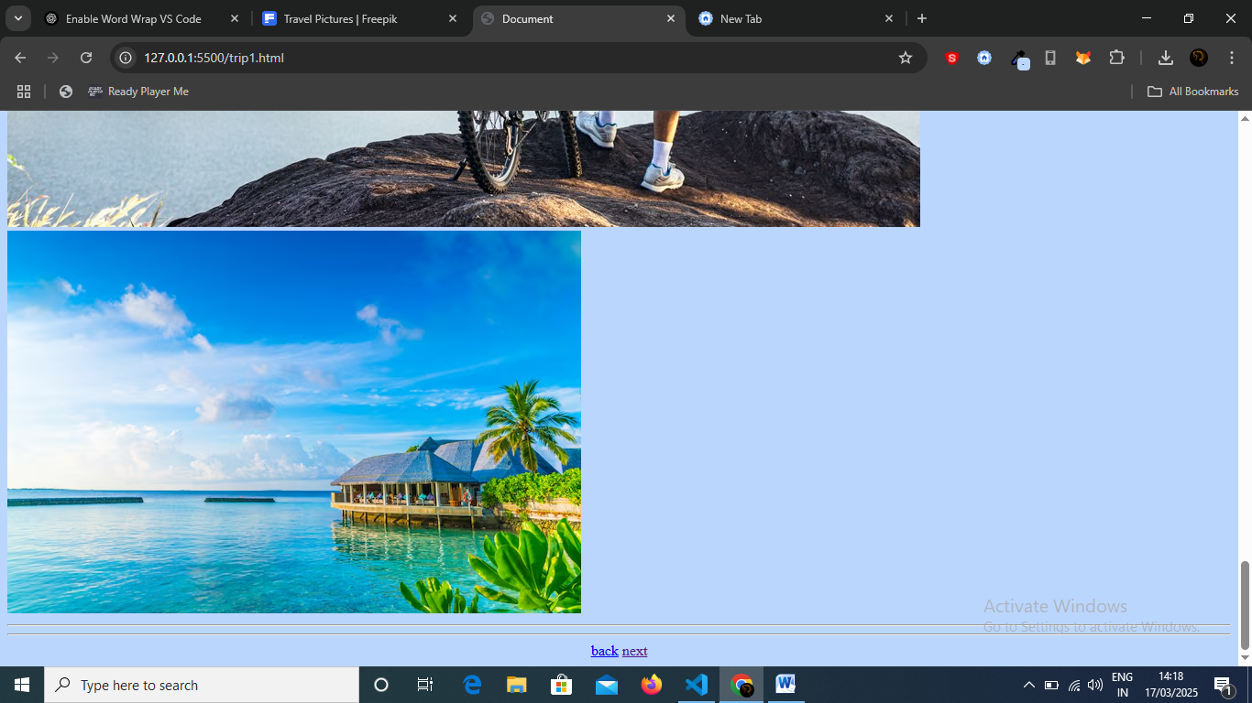
Screen2 :
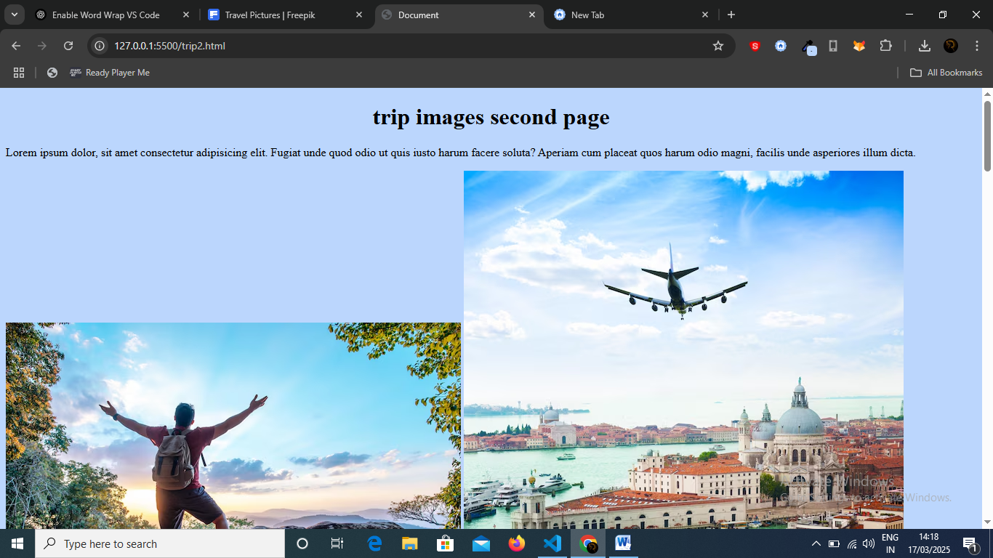

Screen 3:
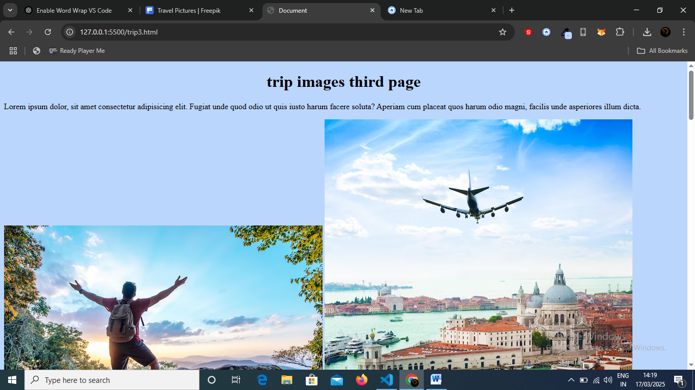
Screen 4:
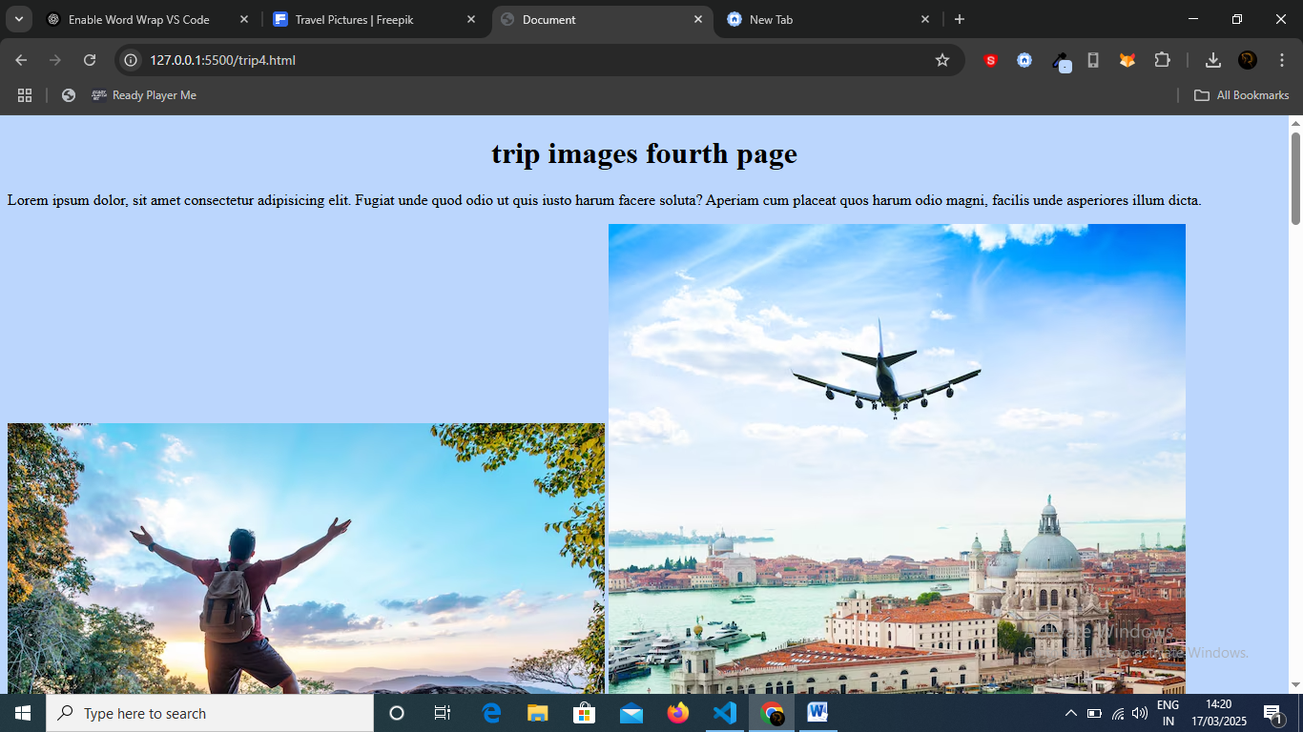
Screen5:
